Predictive Modeling and Risk Scoring for Bank Customer Churn

1. Introduction
The banking industry operates in a highly competitive environment where customer retention is essential for maintaining profitability, strengthening customer relationships, and achieving sustainable business growth. Customers may discontinue their banking relationships due to various factors, including dissatisfaction with banking services, limited engagement, changing financial requirements, and the availability of more attractive alternatives offered by competing institutions. Customer churn, which refers to the loss of existing customers, is therefore a significant concern for banks. Identifying customers who are likely to leave before they actually discontinue their relationship can help financial institutions develop proactive and effective retention strategies.
Traditional approaches to customer retention often rely on historical reports, manual analysis, and reactive interventions after customers have already demonstrated signs of disengagement. Although these approaches provide useful information about past customer behavior, they may not be sufficient to identify emerging churn patterns at an early stage. With the growing availability of customer data and advances in machine learning, predictive analytics offers an opportunity to analyze customer characteristics, discover patterns associated with churn, and estimate the likelihood of customer attrition.
The project “Predictive Bank Customer Churn” focuses on developing a machine learning-based approach to predict customer churn and assess individual customer risk. The project uses historical banking customer data containing attributes such as age, credit score, account balance, tenure, number of products, credit card ownership, active membership status, estimated salary, geography, and gender. The target variable, Exited, indicates whether a customer has left the bank (1) or remained with the bank (0). These attributes are used to identify patterns that may help distinguish customers who churn from those who remain with the institution.
A Gradient Boosting Classifier is used as the predictive model in this project. Gradient Boosting is an ensemble learning technique that combines multiple decision trees sequentially, with each subsequent tree helping to improve the overall model by addressing errors made by earlier trees. The trained model generates a churn probability for an individual customer, providing a quantitative estimate of the customer's likelihood of leaving the bank. These predictions can then be interpreted through risk categories to support the prioritization of customer retention efforts.
In addition to model development, the project incorporates an interactive Streamlit web application that makes the predictive results accessible through a user-friendly dashboard. The application includes a customer churn risk calculator, probability distribution visualization, feature importance dashboard, and What-If Scenario Simulator. The simulator allows users to modify selected customer attributes, such as active membership status and number of banking products, and observe how the model's predicted churn probability changes under hypothetical conditions. This functionality demonstrates how predictive analytics can support exploratory analysis and data-driven decision-making.
The primary objective of this project is to demonstrate how machine learning can be applied to bank customer churn prediction and how individual risk scores can support customer retention planning. By combining predictive modelling, feature importance analysis, scenario simulation, and interactive visualization, the project provides a practical framework for understanding customer churn patterns. The model's predictions are intended to support decision-making rather than replace business judgment, and their practical use depends on appropriate model validation, probability calibration, and evaluation against relevant business requirements.
2. Problem Statement
Despite the availability of rich customer-level data, banks often face challenges in identifying customers who are likely to discontinue their banking relationships. Traditional analytical approaches may not adequately capture complex patterns in customer behaviour or provide timely insights into potential churn. The absence of reliable predictive mechanisms can make it difficult for banks to prioritize retention efforts and allocate resources effectively.
The key problems addressed by the Predictive Bank Customer Churn project are described below.
1. Lack of Accurate Churn Prediction Models: Banks require reliable machine learning models that can analyze historical customer data and estimate the likelihood of customer churn. Without effective predictive models, identifying potentially departing customers before they leave becomes challenging.
2. Absence of Quantitative Churn Risk Scores: Banks need measurable estimates of individual customer churn risk to distinguish between customers with different levels of predicted attrition risk. Without quantitative risk scores, prioritizing customers for retention initiatives can be difficult.
3. Limited Explainability of Churn Drivers: Predicting churn alone is insufficient for effective decision-making. Banks also need to understand which customer attributes contribute most to the model's predictions. Limited visibility into these factors can restrict the development of targeted customer engagement and retention strategies.

3. Primary Objectives
The primary objective of the Predictive Bank Customer Churn project is to develop a machine learning-based solution that predicts customer churn, quantifies individual customer risk, and identifies the key factors influencing churn predictions. The project aims to transform historical banking customer data into actionable insights that support informed decision-making and customer retention planning.
The specific objectives are as follows:
1. Predict Customer Churn with High Accuracy: Develop and evaluate a Gradient Boosting Classifier using historical customer data to distinguish between customers who are likely to leave the bank and those who are likely to remain. Model performance will be assessed using appropriate classification evaluation metrics.
2. Generate Churn Probability Scores: Estimate the probability of churn for individual customers and present the results through an interactive dashboard. These probability scores can help categorize customers into different risk levels and prioritize potential retention efforts.
3. Identify Key Churn Drivers: Analyze feature importance scores to identify customer attributes that contribute most to the model's predictions. This analysis aims to improve understanding of churn patterns and provide insights that can inform customer engagement strategies.
4. Develop an Interactive Predictive Dashboard: Implement a Streamlit web application that allows users to enter customer information, view predicted churn probabilities, explore feature importance, and compare predictions under hypothetical customer scenarios.
4. Secondary Objectives
In addition to the primary objectives, the Predictive Bank Customer Churn project focuses on improving the practical usefulness, interpretability, and flexibility of the churn prediction system. The secondary objectives are as follows:
1. Reduce False Positives in Churn Detection: Minimize the number of customers incorrectly classified as likely to churn when they would actually remain with the bank. Reducing false positives can help avoid unnecessary retention campaigns and improve the efficient allocation of banking resources. This objective requires careful evaluation of the model's precision, recall, and classification threshold.
2. Improve Interpretability of Machine Learning Models: Provide insights into the factors influencing churn predictions through feature importance analysis. By identifying influential customer attributes, the project aims to make model outputs easier to understand and help stakeholders interpret the results more effectively. Feature importance indicates predictive contribution, not necessarily causation.
3. Enable Scenario-Based Churn Risk Analysis: Implement a What-If Scenario Simulator within the Streamlit dashboard to evaluate how predicted churn probabilities change when selected customer attributes are modified. For example, users can compare predictions for different active membership statuses and numbers of banking products while keeping other customer attributes constant.
4. Enhance Decision Support for Customer Retention: Present churn probabilities, risk categories, and feature importance through interactive visualizations to help users explore customer risk and identify cases that may warrant further review.
Expected outcome: These secondary objectives aim to make the churn prediction system more useful for exploratory analysis and customer retention planning. Their achievement should be verified through model evaluation, comparison of false-positive rates, and testing of the dashboard's scenario simulation functionality.

5. Dataset Description
The dataset used in the Predictive Bank Customer Churn project contains customer demographic details, financial information, banking product usage, and customer activity indicators. These attributes are used to analyze customer behavior and develop a machine learning model to predict the likelihood of customer churn.

5.1 Description of Dataset Attributes
Column | Description
CustomerId | Unique customer identifier
Surname | Customer surname
CreditScore | Customer creditworthiness
Geography | Customer's country: France, Spain, or Germany
Gender | Customer gender: Male or Female
Age | Customer age in years
Tenure | Number of years the customer has been with the bank
Balance | Customer's account balance
NumOfProducts | Number of banking products held by the customer
HasCrCard | Indicates credit card ownership
IsActiveMember | Indicates whether the customer is an active member
EstimatedSalary | Estimated annual salary of the customer
Exited | Indicates whether the customer has left the bank; target variable

5.2 Target Variable
The target variable is Exited, which identifies the customer's churn status:
- 1 — Churned: The customer has left the bank.
- 0 — Retained: The customer has remained with the bank.
The Gradient Boosting Classifier uses the selected customer attributes to predict the probability of churn.
5.3 Feature Categories
For analysis, the dataset attributes can be grouped into the following categories:
- Demographic information: Age, Gender, and Geography.
- Financial information: CreditScore, Balance, and EstimatedSalary.
- Banking relationship and engagement: Tenure, NumOfProducts, HasCrCard, and IsActiveMember.
- Customer identification: CustomerId and Surname.
- Prediction target: Exited.
CustomerId and Surname are identifying attributes and should be assessed carefully before model training because they may not provide meaningful generalizable information about churn.
5.4 Application of the Dataset
The dataset supports the development and evaluation of the churn prediction model. It is used to identify patterns associated with customer attrition, estimate customer-level churn probabilities, and examine feature importance. The trained model is integrated into a Streamlit dashboard that provides churn risk assessment, probability visualization, and What-If scenario simulation.

6. Analytical Methodology
6. Data Preprocessing
Data preprocessing is an essential step in the Predictive Bank Customer Churn project. It involves examining the dataset, validating data quality, removing irrelevant attributes, transforming categorical variables, and preparing the data for machine learning. The objective is to ensure that the dataset is suitable for training the Gradient Boosting Classifier.
6.1 Missing Value Handling
The dataset was examined for missing or null values across all columns. The analysis found no missing values in the dataset. Therefore, no imputation techniques, such as mean, median, or mode imputation, were required.
6.2 Duplicate Record Removal
The dataset was checked for duplicate records. No duplicate records were found, indicating that no duplicate-removal operation was required during preprocessing.
6.3 Removal of Non-Informative Features
The CustomerId and Surname columns were excluded from model training because they primarily serve as customer identifiers and do not directly represent meaningful customer behavior.
Removing these attributes helps simplify the feature set and reduces the risk of the model learning irrelevant patterns from customer identification information.
6.4 Categorical Variable Encoding
Categorical variable encoding is a data preprocessing technique used to convert categorical data into a numerical format suitable for machine learning algorithms. In this project, one-hot encoding was applied to the Geography and Gender columns to represent customer categories using binary indicator variables.
One-Hot Encoding Results
The original categorical columns were transformed into the following binary features:
- Geography_Germany
- Geography_Spain
- Gender_Male
France and Female serve as the reference categories in this encoding configuration. When a customer belongs to either reference category, the corresponding encoded columns contain False (equivalent to 0). A value of True (equivalent to 1) indicates membership in the represented category.

6.5 Numerical Feature Preparation
Numerical variable preparation is an important preprocessing step in the Predictive Bank Customer Churn project. Numerical features may have different measurement scales and ranges, which can affect the training process of certain machine learning algorithms. To address this, standardization using feature scaling was applied to selected numerical variables.
Standardization of Numerical Features
The following numerical variables were standardized:
- CreditScore
- Age
- Tenure
- Balance
- NumOfProducts
- EstimatedSalary
Standardization transforms numerical values so that each feature has approximately a mean of 0 and a standard deviation of 1. This is commonly performed using the StandardScaler technique.
The transformation is represented by the formula:
$$z=\frac{x-μ}{σ}$$
Where:
- z = standardized value
- x = original feature value
- m = mean of the feature
- sigma = standard deviation of the feature

7. Feature Engineering
7.1 Balance-to-Salary Ratio
Feature engineering is the process of creating new variables from existing dataset attributes to capture meaningful relationships that may improve machine learning analysis. In the Predictive Bank Customer Churn project, the Balance-to-Salary Ratio was created to represent the relationship between a customer's account balance and estimated annual salary.
1. Feature Definition
The feature BalanceSalaryRatio is calculated using the following formula:

$$\text{BalanceSalaryRatio}=\frac{\text{Balance}}{\text{EstimatedSalary}+1}$$
Adding 1 to the denominator prevents division by zero when the estimated salary is zero.
2. Descriptive Statistics
The following table presents the descriptive statistics for BalanceSalaryRatio across 10,000 customer records.
Statistic | Value
Count | 10,000
Mean | 3.790150
Standard deviation | 100.055758
Minimum | 0.000000
25th percentile (Q1) | 0.000000
Median (Q2) | 0.746998
75th percentile (Q3) | 1.514002
Maximum | 9,770.883148

3. Interpretation of Results
- Mean (3.79): The average ratio is approximately 3.79. However, this value is strongly influenced by extreme observations.
- Median (0.747): Half of the customers have a ratio at or below approximately 0.747, indicating that the distribution is not symmetric.
- First quartile (0.00): At least 25% of customers have a zero balance-to-salary ratio, consistent with customers whose account balance is zero when salary is positive.
- Standard deviation (100.06): The large standard deviation indicates substantial variability in the feature.
- Maximum (9,770.88): The unusually high maximum suggests extreme ratios, potentially caused by very small, estimated salaries relative to account balances.
4. Significance for Churn Prediction
The Balance-to-Salary Ratio provides an additional perspective on a customer's financial position by comparing account balance with estimated salary. It may help the model identify patterns associated with different customer financial profiles.
However, a high ratio does not automatically indicate a higher likelihood of churn. Its relationship with churn must be established through model analysis rather than assumed.
5. Conclusion
The engineered BalanceSalaryRatio feature adds a relative financial measure to the original customer attributes. Its descriptive statistics reveal a highly skewed distribution with extreme values. Therefore, the feature's distribution and influence on model predictions should be reviewed during exploratory data analysis and model validation.

7. 2. Product Density Indicator
Feature engineering involves creating new variables from existing dataset attributes to capture additional patterns in customer behavior. In the Predictive Bank Customer Churn project, the Product Density Indicator (ProductDensity) was created using the number of banking products held by a customer and the customer's tenure with the bank.
1. Feature Definition
The Product Density Indicator is calculated using the following formula:

$$\text{ProductDensity}=\frac{\text{NumOfProducts}}{\text{Tenure}+1}$$
2. Sample of Engineered Feature

Customer Index | NumOfProducts | Tenure | ProductDensity
0 | 1 | 2 | 0.333333
1 | 1 | 1 | 0.500000
2 | 3 | 8 | 0.333333
3 | 2 | 1 | 1.000000
4 | 1 | 2 | 0.333333

3. Interpretation of Results
- Customer 0: The customer holds one banking product and has two years of tenure. The resulting product density is approximately 0.333.
- Customer 1: The customer holds one banking product and has one year of tenure, producing a product density of 0.5.
- Customer 2: The customer holds three banking products and has eight years of tenure, producing a product density of approximately 0.333.
- Customer 3: The customer holds two banking products and has one year of tenure, producing a product density of 1.0.
- Customer 4: The customer holds one banking product and has two years of tenure, producing a product density of approximately 0.333.
The values demonstrate how the indicator represents the number of banking products relative to tenure. Customers with more products relative to their tenure receive higher values, while customers with longer tenure relative to their product count generally receive lower values.
4. Significance for Churn Prediction
The Product Density Indicator provides the model with an additional feature describing the relationship between product ownership and customer tenure. It may help identify patterns associated with different customer banking relationships.
However, a higher or lower product density does not automatically indicate greater churn risk. Its usefulness must be assessed through model training and evaluation.
5. Conclusion
The ProductDensity feature supplements the original dataset by combining NumOfProducts and Tenure into a single numerical indicator. This engineered feature is included in the project's feature set to help the Gradient Boosting Classifier explore potential relationships between product usage, customer tenure, and churn behavior.

7.3 Engagement-product interaction
Feature engineering is used to create new variables that capture relationships between existing customer attributes. In the Predictive Bank Customer Churn project, the Engagement–Product Interaction (EngagementProductInteraction) feature combines the customer's active membership status with the number of banking products held.
1. Feature Definition
The feature is calculated using the following formula:

$$\text{EngagementProductInteraction}=\text{IsActiveMember}×\text{NumOfProducts}$$

Here, IsActiveMember is a binary variable:
- 1 indicates that the customer is an active member.
- 0 indicates that the customer is not an active member.
2. Sample of Engineered Feature

Customer Index | IsActiveMember | NumOfProducts | EngagementProductInteraction
0 | 1 | 1 | 1
1 | 1 | 1 | 1
2 | 0 | 3 | 0
3 | 0 | 2 | 0
4 | 1 | 1 | 1

3. Interpretation of Results
- Customer 0: The customer is active and holds one banking product. The interaction value is 1.
- Customer 1: The customer is active and holds one banking product. The interaction value is 1.
- Customer 2: The customer is inactive and holds three banking products. The interaction value is 0.
- Customer 3: The customer is inactive and holds two banking products. The interaction value is 0.
- Customer 4: The customer is active and holds one banking product. The interaction value is 1.
The feature takes a value of zero whenever the customer is inactive, regardless of the number of products held. For active customers, the interaction value equals their number of banking products.
4. Significance for Churn Prediction
This interaction feature enables the Gradient Boosting Classifier to consider the combined relationship between customer activity and product ownership. It may help the model distinguish between active and inactive customers with different levels of product usage.
However, the feature alone does not establish whether an active customer or a customer with more products is less likely to churn. Its predictive contribution must be evaluated using model results.
5. Conclusion
The EngagementProductInteraction feature combines customer activity and product ownership into a single variable. It enriches the dataset with information about the interaction between these attributes and supports the analysis of customer churn patterns through machine learning.

7.4 EngagementProductInteraction
The EngagementProductInteraction feature is an engineered variable that combines customer activity status with the number of banking products held by a customer. It is designed to capture the interaction between customer engagement and product ownership for the Predictive Bank Customer Churn model.
Feature Calculation
The feature is calculated using the following formula:
$$\text{E}\text{ngagementProductInteraction}=\text{IsActiveMember}×\text{NumOfProducts}$$

Customer Index | IsActiveMember | NumOfProducts | EngagementProductInteraction
0 | 1 | 1 | 1
1 | 1 | 1 | 1
2 | 0 | 3 | 0
3 | 0 | 2 | 0
4 | 1 | 1 | 1

Interpretation
- When IsActiveMember = 1, the interaction value equals the number of products held by the customer.
- When IsActiveMember = 0, the interaction value is zero, irrespective of the number of products.
For example, Customer 2 holds three banking products but is inactive. Therefore, the interaction value is 0 X 3 = 0.
Significance for Churn Prediction
This feature enables the Gradient Boosting Classifier to consider customer activity and product ownership together. It may help identify patterns associated with different customer engagement levels and banking product usage.
Conclusion: The EngagementProductInteraction feature adds information about the combined relationship between customer activity and product ownership. Its actual contribution to churn prediction should be assessed through model evaluation and feature importance analysis.

7.5 Age–Tenure Interaction Feature
The AgeTenureInteraction feature is an engineered variable that combines a customer's age with the number of years the customer has maintained a relationship with the bank. It is designed to capture the interaction between customer age and banking tenure for the Predictive Bank Customer Churn model.
1. Feature Calculation
The feature is calculated by multiplying the customer's age by their tenure.
$$\text{AgeTenureInteraction}=\text{Age}×\text{Tenure}$$

2. Sample of Engineered Feature
Customer Index | Age | Tenure | AgeTenureInteraction
0 | 42 | 2 | 84
1 | 41 | 1 | 41
2 | 42 | 8 | 336
3 | 39 | 1 | 39
4 | 43 | 2 | 86
3. Interpretation of Results
- Customer 0: Age 42 and tenure 2 years produce an interaction value of 42 times 2 = 84.
- Customer 1: Age 41 and tenure 1 year produce an interaction value of 41 times 1 = 41
- Customer 2: Age 42 and tenure 8 years produce an interaction value of 42 times 8 = 336.
- Customer 3: Age 39 and tenure 1 year produce an interaction value of 39 times 1 = 39.
- Customer 4: Age 43 and tenure 2 years produce an interaction value of 43 times 2 = 86.
The results demonstrate that the interaction value increases with the product of age and tenure. For example, Customer 2 has a higher interaction value than Customer 0 because the customer has a longer banking tenure.
4. Significance for Churn Prediction
The AgeTenureInteraction feature enables the Gradient Boosting Classifier to consider age and tenure jointly rather than only as separate variables. It may help the model identify patterns associated with different combinations of customer age and relationship duration.
However, a higher interaction value does not automatically indicate a higher or lower churn risk. Its predictive usefulness must be assessed through model evaluation.

5. Conclusion
The AgeTenureInteraction feature enriches the dataset by combining two customer attributes into a single numerical variable. This feature supports the analysis of potential relationships between customer age, banking tenure, and churn behavior within the predictive modeling framework.

8. Train-Test Strategy
The train-test strategy is an essential step in developing a machine learning model. It involves dividing the available dataset into separate training and testing subsets to evaluate how effectively the model predicts customer churn on unseen data.
In the Predictive Bank Customer Churn project, a stratified train-test split was used to maintain the proportion of churned and retained customers in both subsets. This approach is particularly useful when the target variable contains unequal class proportions.
8.1 Stratified Train-Test Split
The target variable, Exited, represents two customer classes:
- Exited = 0: Customers who remained with the bank.
- Exited = 1: Customers who left the bank.
The original dataset contained approximately 79.63% retained customers and 20.37% churned customers. Stratification preserves these proportions as closely as possible in the training and testing datasets.

Dataset | Retained Customers (Exited = 0) | Churned Customers (Exited = 1)
Original dataset | 79.63% | 20.37%
Training dataset | 79.625% | 20.375%
Testing dataset | 79.65% | 20.35%

Interpretation of Results
Original Dataset: Approximately 79.63% of customers remained with the bank, while 20.37% exited. This indicates a moderate class imbalance, with retained customers forming the majority class.
Training Dataset: The training subset contains 79.625% retained customers and 20.375% churned customers. These proportions closely match the original distribution, helping the model learn from a representative class distribution.
Testing Dataset: The testing subset contains 79.65% retained customers and 20.35% churned customers. This closely reflects the original distribution and provides a representative basis for evaluating model performance.
Importance of Stratification
Stratified splitting provides several benefits:
- Preserves class proportions: Both customer classes remain represented in proportions close to those of the original dataset.
- Supports reliable evaluation: The testing data reflects the original churn distribution more closely.
- Reduces sampling variation: It helps prevent disproportionate representation of churned or retained customers in either subset.
- Supports fair model assessment: It provides a more representative basis for evaluating metrics such as precision, recall, F1-score, and ROC-AUC.
Conclusion
The stratified train-test strategy successfully preserved the distribution of the Exited target variable across the original, training, and testing datasets. The similar class proportions indicate that the split maintained a representative distribution of churned and retained customers. This provides a suitable foundation for training the Gradient Boosting Classifier and evaluating its predictive performance.

8.2 Preservation of Churn Class Distribution
In the Predictive Bank Customer Churn project, stratification was used during the train-test split to preserve the class distribution of the target variable, Exited. This ensures that the proportions of retained and churned customers remain approximately consistent across the original dataset, training dataset, and testing dataset.
Class Distribution Results
Dataset | Exited = 0 (Retained) | Exited = 1 (Churned)
Original distribution | 79.63% | 20.37%
Training distribution | 79.625% | 20.375%
Testing distribution | 79.65% | 20.35%

Interpretation
- Original dataset: Approximately 79.63% of customers were retained, while 20.37% had exited the bank.
- Training dataset: The retained and churned customer proportions were 79.625% and 20.375%, respectively.
- Testing dataset: The retained and churned customer proportions were 79.65% and 20.35%, respectively.
The results show that the training and testing distributions closely match the original class distribution. This indicates that the stratified split successfully maintained a representative proportion of both classes.
Importance of Preserving Class Distribution
Preserving the churn class distribution helps ensure that the model is trained and evaluated on datasets with similar proportions of churned and retained customers. It also reduces the risk of obtaining an unrepresentative test set due to random sampling variation.
Since churned customers represent approximately 20.37% of the original dataset, it is important to evaluate the model using metrics such as precision, recall, F1-score, and ROC-AUC, rather than relying on accuracy alone.

Conclusion
The stratified train-test split maintained the original churn class distribution with minimal variation across the training and testing datasets. This provides a consistent foundation for developing and evaluating the Gradient Boosting Classifier. However, preserving class proportions does not by itself guarantee high predictive accuracy or eliminate all forms of sampling bias.

8.3 Optional K-Fold Cross-Validation
K-fold cross-validation is a model evaluation technique used to assess how consistently a machine learning model performs across different subsets of the training data. In this project, five-fold cross-validation was performed to evaluate classification performance.
The dataset is divided into five folds. In each iteration, four folds are used for training and the remaining fold is used for validation. This process is repeated five times, with each fold serving as the validation set once.
1. Cross-Validation Results
The following results were obtained during cross-validation:

Fold | Accuracy
Fold 1 | 80.31%
Fold 2 | 81.25%
Fold 3 | 82.19%
Fold 4 | 80.69%
Fold 5 | 80.63%
Mean CV Accuracy | 81.01%
Standard Deviation | 0.66 percentage points

2. Interpretation of Results
Mean Cross-Validation Accuracy: 81.01%
The model achieved an average accuracy of approximately 81.01% across the five validation folds. This indicates that it correctly classified approximately 81 out of every 100 observations on average across these folds.
Standard Deviation: 0.66 percentage points
The relatively small standard deviation indicates that the accuracy scores varied only slightly across the five folds. This suggests consistent accuracy across the evaluated subsets, although it does not by itself establish that the model generalizes well to new customers.
3. Convergence Warning Observed
During cross-validation, scikit-learn generated a ConvergenceWarning for Logistic Regression. The warning indicates that the lbfgs solver reached its maximum number of iterations before convergence.
This warning means that the Logistic Regression optimization may not have fully converged, so its results should be reviewed before drawing final conclusions.
Possible corrective measures include:
- Increasing max_iter, for example, to 2,000.
- Standardizing numerical features.
- Using a pipeline to ensure scaling is fitted only on each training fold and then applied to its validation fold.
The warning relates to the Logistic Regression model; it should not automatically be interpreted as a problem with your separate Gradient Boosting model.

4. Conclusion
Five-fold cross-validation produced a mean accuracy of 81.01%, with a standard deviation of 0.66 percentage points. These results suggest relatively consistent accuracy across the validation folds. However, accuracy alone is insufficient for evaluating a churn prediction model, particularly when churned customers represent a minority class.
Further evaluation using precision, recall, F1-score, ROC-AUC, and a confusion matrix is recommended. The Logistic Regression convergence warning should also be addressed if Logistic Regression is included in the final model comparison.

9. Model Development
9.1 Logistic Regression: Model Evaluation Results
The Logistic Regression model was evaluated on the test dataset to establish a baseline for the Predictive Bank Customer Churn project. The evaluation included accuracy, precision, recall, F1-score, confusion matrix, and ROC-AUC.
1. Model Performance Summary
Evaluation Metric | Result
Accuracy | 80.65%
Precision — Retained customers (Class 0) | 82%
Recall — Retained customers (Class 0) | 97%
F1-score — Retained customers (Class 0) | 0.89
Precision — Churned customers (Class 1) | 58%
Recall — Churned customers (Class 1) | 18%
F1-score — Churned customers (Class 1) | 0.27
ROC-AUC Score | 0.7700

2. Confusion Matrix Analysis
The confusion matrix obtained from the test dataset is:
$$\left[\begin{matrix}1540 & 53 \\ 334 & 73\end{matrix}\right]$$
The model correctly classified 1,540 retained customers and 73 churned customers. However, it failed to identify 334 customers who actually churned, classifying them as retained.
3. Interpretation of Results
Accuracy — 80.65%
The model correctly classified 1,613 out of 2,000 customers. Although the accuracy is approximately 81%, this metric alone does not adequately describe the model's effectiveness at detecting churn.
Churn precision — 58%
Of the customers predicted to churn, approximately 58% actually churned. This indicates moderate precision for the churn class.
Churn recall — 18%
The model identified only 73 of the 407 customers who actually churned. Its churn recall is approximately 17.94%, meaning that it missed about 82% of actual churn cases.
ROC-AUC — 0.7700
The ROC-AUC score indicates that the model has some ability to distinguish between churned and retained customers. However, the score does not establish that its predicted probabilities are well calibrated.
4. Convergence Warning
The training output also reported a Convergence Warning from Logistic Regression. The lbfgs solver reached its iteration limit before convergence.
Before finalizing this baseline, consider increasing max_iter and ensuring numerical features are standardized within a preprocessing pipeline. Then rerun the evaluation to check whether the results change.
5. Conclusion
The Logistic Regression model achieved 80.65% accuracy and a ROC-AUC of 0.7700, providing a useful baseline for comparison with the Gradient Boosting Classifier. However, its churn recall of approximately 18% is a major limitation: most customers who actually churned were not detected.

9.2 Tree-Based Models
Tree-based machine learning models are widely used for classification tasks because they can capture nonlinear relationships and interactions among input features. In the Predictive Bank Customer Churn project, two tree-based algorithms—Decision Tree and Random Forest—were evaluated to determine their effectiveness in classifying bank customers as churned or retained.
9.2.1 Decision Tree Classifier
The Decision Tree Classifier is a supervised machine learning algorithm that makes predictions by splitting the dataset into smaller groups based on feature values. Each split aims to separate customers into classes, such as churned and retained customers.
Model evaluation results
Evaluation Metric | Retained (Class 0) | Churned (Class 1)
Precision | 0.86 | 0.80
Recall | 0.97 | 0.40
F1-score | 0.92 | 0.53
Support | 1,593 | 407
Overall test accuracy
85.75%
The Decision Tree correctly classified 1,715 out of 2,000 customers.
Confusion matrix
$$\left[\begin{matrix}1552 & 41 \\ 244 & 163\end{matrix}\right]$$
Interpretation
- Accuracy of 85.75%: The model correctly classified approximately 86% of the test observations.
- Churn precision of 80%: Of the customers predicted to churn, approximately 80% actually belonged to the churn class.
- Churn recall of 40%: The model identified 163 of the 407 actual churned customers.
- Churn F1-score of 0.53: The model demonstrates a moderate balance between precision and recall for churn detection.
The Decision Tree performs well in identifying retained customers, with a recall of approximately 97%. However, it misses 244 actual churned customers. This limitation indicates that further improvement in churn detection may be necessary.
9.2.2 Random Forest Classifier
Random Forest is an ensemble learning algorithm that combines predictions from multiple decision trees. Each tree is trained using a randomized subset of the training data and features, and their predictions are aggregated to produce the final classification.
This approach can improve predictive stability and reduce the risk of overfitting compared with a single decision tree, depending on the dataset and model configuration.
Model evaluation results

Evaluation Metric | Retained (Class 0) | Churned (Class 1)
Precision | 0.91 | 0.60
Recall | 0.89 | 0.64
F1-score | 0.90 | 0.62
Support | 1,593 | 407

Confusion matrix

$$\left[\begin{matrix}1415 & 178 \\ 145 & 262\end{matrix}\right]$$
Interpretation
- Accuracy of 83.85%: The model correctly classified approximately 84% of the test observations.
- Churn precision of 60%: Approximately 60% of the customers predicted to churn actually churned.
- Churn recall of 64%: The model correctly identified 262 of the 407 actual churned customers.
- Churn F1-score of 0.62: The model provides a better balance between churn precision and recall than the Decision Tree.
Although Random Forest achieved lower overall accuracy than the Decision Tree, it identified substantially more churned customers. It missed 145 actual churn cases, compared with 244 for the Decision Tree.
9.2.3 Comparison of Decision Tree and Random Forest
Metric | Decision Tree | Random Forest | Better result
Accuracy | 85.75% | 83.85% | Decision Tree
Churn precision | 80% | 60% | Decision Tree
Churn recall | 40% | 64% | Random Forest
Churn F1-score | 0.53 | 0.62 | Random Forest
Missed churn cases | 244 | 145 | Random Forest

Conclusion
The Decision Tree achieved the highest accuracy at 85.75%, making it the stronger model when overall classification accuracy is the primary consideration. However, the Random Forest achieved a higher churn recall of 64% and a higher churn F1-score of 0.62.
For a bank customer churn project, identifying customers who may leave is an important business objective. Therefore, Random Forest provides the stronger churn-detection performance among these two models, while the Decision Tree offers higher accuracy and precision.

9.3 Advanced Model:
A. Gradient Boosting Classifier
Gradient Boosting is an ensemble machine learning algorithm that combines multiple decision trees sequentially to improve predictive performance. Each subsequent tree attempts to correct errors made by the previous trees, enabling the model to learn complex patterns and relationships within the dataset.
In the Predictive Bank Customer Churn project, the Gradient Boosting Classifier was developed to predict whether a bank customer is likely to leave or remain with the bank. Its performance was evaluated using accuracy, precision, recall, F1-score, the confusion matrix, and ROC-AUC.
Model Evaluation Results

Evaluation Metric | Retained (Class 0) | Churned (Class 1)
Precision | 0.88 | 0.79
Recall | 0.97 | 0.49
F1-score | 0.92 | 0.60
Support | 1,593 | 407

Confusion Matrix Analysis
The confusion matrix obtained from the test dataset is:
$$\left[\begin{matrix}1539 & 54 \\ 208 & 199\end{matrix}\right]$$

Actual / Predicted | Predicted Retained | Predicted Churned
Actually retained | 1,539 | 54
Actually churned | 208 | 199

The results indicate that:
- True negatives (1,539): Retained customers correctly classified as retained.
- False positives (54): Retained customers incorrectly classified as likely to churn.
- False negatives (208): Churned customers incorrectly classified as retained.
- True positives (199): Churned customers correctly identified by the model.
The model correctly identified 199 of the 407 actual churned customers, while 208 churn cases remained undetected.
Interpretation of Performance
Accuracy — 86.90%
The model correctly classified approximately 87% of the customers in the test dataset. This is the highest accuracy among the three models evaluated so far: Decision Tree (85.75%), Random Forest (83.85%), and Gradient Boosting (86.90%).
Churn precision — 79%
Approximately 79% of customers predicted to churn actually belonged to the churn class. This suggests that the model's churn predictions have relatively good precision.
Churn recall — 49%
The model detected approximately 49% of the actual churned customers. Although this is better than the Logistic Regression baseline's recall of approximately 18% and the Decision Tree's recall of 40%, the model still misses slightly more than half of actual churn cases.
Churn F1-score — 0.60
The F1-score balances precision and recall for the churn class. A score of 0.60 indicates a more balanced result than the Logistic Regression baseline, whose churn F1-score was 0.27.
ROC-AUC — 0.8682
The ROC-AUC score indicates good discrimination between churned and retained customers. More specifically, it measures the model's ability to rank randomly selected churned customers above randomly selected retained customers across classification thresholds. It does not, by itself, establish that the predicted probabilities are calibrated.

Conclusion
The Gradient Boosting Classifier achieved 86.90% accuracy and a ROC-AUC score of 0.8682, demonstrating strong overall classification and discrimination performance among the models evaluated so far.
Its churn precision of 79% indicates that most customers flagged as potential churners were actual churners in the test dataset. However, its churn recall of 49% shows that further improvement is needed to identify more customers at risk of leaving the bank.
Overall, Gradient Boosting is a promising candidate for the final predictive model. The final selection should consider churn detection performance, false-positive and false-negative costs, probability calibration, and the model's performance on unseen data—not accuracy alone.

9.4 Advanced Model: XGBoost Classifier
XGBoost (Extreme Gradient Boosting) is an advanced ensemble learning algorithm based on gradient boosting. It builds decision trees sequentially, with each new tree helping to correct errors made by previous trees. XGBoost incorporates regularization techniques and computational optimizations to improve model efficiency and control overfitting.
In the Predictive Bank Customer Churn project, XGBoost was evaluated as an alternative to the Gradient Boosting Classifier to determine its effectiveness in distinguishing between retained and churned bank customers.
9.4.1 Model Evaluation Results
Evaluation Metric | Retained (Class 0) | Churned (Class 1)
Precision | 0.88 | 0.80
Recall | 0.97 | 0.47
F1-score | 0.92 | 0.59
Support | 1,593 | 407

9.4.2 Confusion Matrix Analysis
The confusion matrix obtained from the test dataset is
$$\left[\begin{matrix}1544 & 49 \\ 214 & 193\end{matrix}\right]$$

Actual / Predicted | Predicted Retained | Predicted Churned
Actually retained | 1,544 | 49
Actually churned | 214 | 193
The results indicate that:
- True negatives (1,544): Retained customers correctly classified as retained.
- False positives (49): Retained customers incorrectly classified as likely to churn.
- False negatives (214): Churned customers incorrectly classified as retained.
- True positives (193): Churned customers correctly identified by the model.
9.4.3 Interpretation of Results
Accuracy — 86.85%
The model correctly classified approximately 87% of customers in the test dataset. Its accuracy is very close to that of the Gradient Boosting Classifier, which achieved 86.90%.
Churn precision — 80%
Approximately 80% of customers predicted to churn actually belonged to the churn class. This indicates relatively strong precision among customers flagged as potential churners.
Churn recall — 47%
The model identified 193 of the 407 actual churned customers. However, it missed 214 churn cases, demonstrating that further improvement in churn detection may be necessary.
Churn F1-score — 0.59
The F1-score balances precision and recall for the churn class. The score of 0.59 indicates a reasonable balance, although the model does not identify all customers who leave the bank.
ROC-AUC — 0.8679
The ROC-AUC score indicates good discrimination between churned and retained customers across different classification thresholds. It is important to note that ROC-AUC measures ranking ability rather than the calibration of predicted probabilities.

9.4.4 Comparison with Gradient Boosting
Metric | Gradient Boosting | XGBoost
Accuracy | 86.90% | 86.85%
Churn precision | 79% | 80%
Churn recall | 49% | 47%
Churn F1-score | 0.60 | 0.59
ROC-AUC | 0.8682 | 0.8679
False positives | 54 | 49
False negatives | 208 | 214

The two models demonstrate very similar overall performance. Gradient Boosting has marginally higher accuracy, churn recall, F1-score, and ROC-AUC, while XGBoost has slightly higher churn precision and fewer false positives.
Conclusion
The XGBoost Classifier achieved 86.85% accuracy and a ROC-AUC score of 0.8679, demonstrating strong overall classification performance. However, its churn recall of 47% indicates that more than half of actual churn cases were not detected at the evaluated classification threshold.
Compared with XGBoost, the Gradient Boosting Classifier performed marginally better on most of the reported overall and churn-detection metrics. Therefore, based on these results, Gradient Boosting is the stronger candidate of the two models for the final churn prediction system. The final choice should still consider validation results, probability calibration, and the business consequences of missed churn cases and unnecessary retention interventions.

10. Comparison of Model Performance
The following table summarizes the evaluation results obtained on the 2,000-record test dataset.

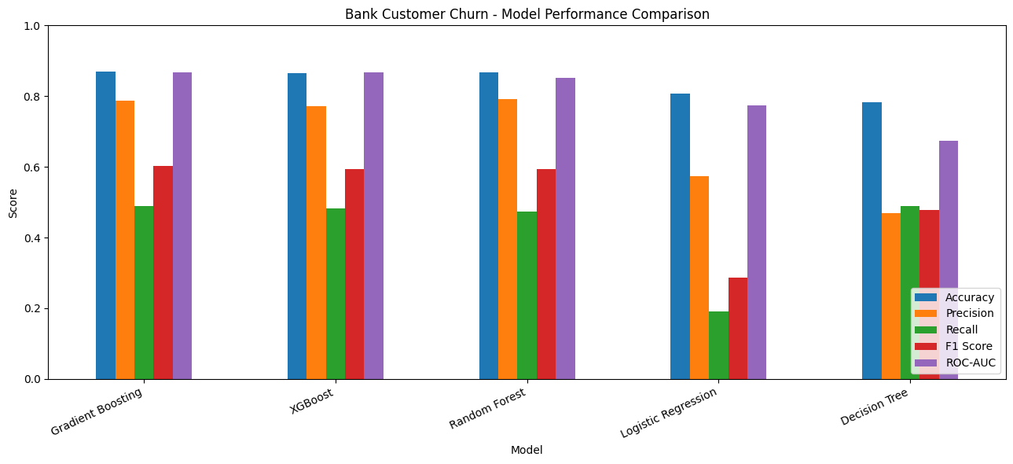

Model | Accuracy | Churn Precision | Churn Recall | Churn F1-score | ROC-AUC
Logistic Regression | 80.65% | 58% | 18% | 0.27 | 0.7700
Decision Tree | 85.75% | 80% | 40% | 0.53 | Not provided
Random Forest | 83.85% | 60% | 64% | 0.62 | Not provided
Gradient Boosting | 86.90% | 79% | 49% | 0.60 | 0.8682
XGBoost | 86.85% | 80% | 47% | 0.59 | 0.8679

Why Gradient Boosting is the recommended choice
- Highest accuracy: Its 86.90% accuracy is marginally higher than XGBoost's 86.85%.
- Best reported ROC-AUC: Its ROC-AUC of 0.8682 is slightly higher than XGBoost's 0.8679, indicating strong discrimination between churned and retained customers.
- Good churn precision: Approximately 79% of customers predicted to churn actually churned in the test set.
- Suitable for your dashboard: It is already the model integrated into your Streamlit application for churn probability estimation, feature importance, and What-If scenario analysis.
- Five machine learning algorithms—Logistic Regression, Decision Tree, Random Forest, Gradient Boosting, and XGBoost—were evaluated for predicting bank customer churn. Their performance was compared using accuracy, precision, recall, F1-score, and ROC-AUC, where available.
- Among the evaluated models, Gradient Boosting achieved the highest overall test accuracy of 86.90% and the highest reported ROC-AUC of 0.8682. It also achieved a churn precision of 79% and a churn recall of 49%, demonstrating good discrimination and relatively high precision for identifying potential churners. XGBoost produced comparable results, with 86.85% accuracy and a ROC-AUC of 0.8679.
- Random Forest achieved the highest churn recall of 64% and the highest churn F1-score of 0.62 among the five models. This indicates that it identified a greater proportion of actual churners, although its overall accuracy was lower at 83.85%. Logistic Regression showed the weakest churn detection performance, with a churn recall of 18%, while the Decision Tree achieved 85.75% accuracy but a churn recall of 40%.
- Based on the current evaluation results and the requirements of the project, Gradient Boosting was selected as the final model for the Streamlit-based predictive banking churn application. Its strong overall accuracy, highest reported ROC-AUC, and relatively high churn precision make it a suitable candidate for customer-level churn probability estimation and interactive risk analysis. Nevertheless, Random Forest remains a relevant alternative when identifying a larger proportion of churned customers is the primary business objective.

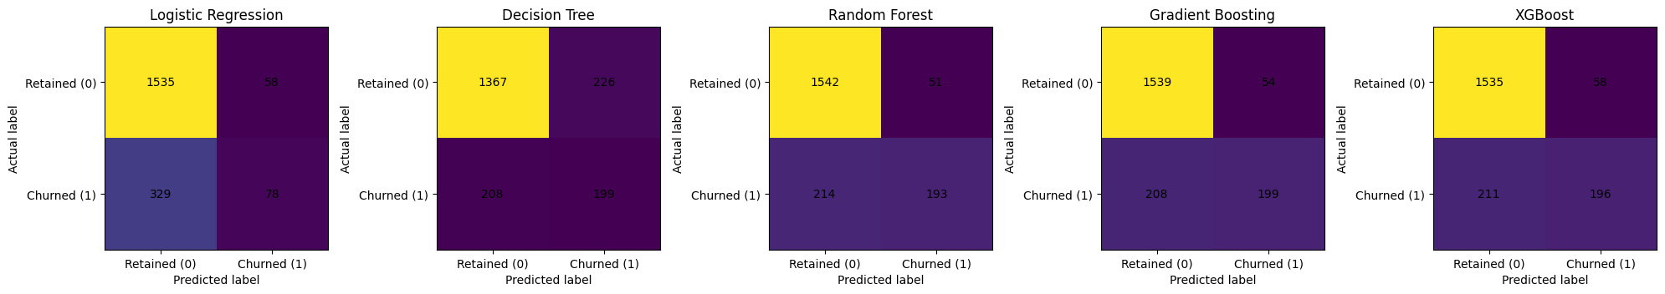

The confusion matrices compare five models for predicting bank customer churn.
- Logistic Regression: Correctly identifies 78 churned customers but misses 329 actual churners.
- Decision Tree: Correctly identifies 199 churners and performs better than Logistic Regression at detecting churn.
- Random Forest: Correctly identifies 193 churners and retains the highest number of actual retained customers among the models shown.
- Gradient Boosting: Correctly identifies 199 churners, with 208 actual churners missed.
- XGBoost: Correctly identifies 196 churners and correctly classifies 1,535 retained customers.
Overall conclusion: Decision Tree and Gradient Boosting identify the most churners correctly (199 each). Logistic Regression misses the most churners (329). If detecting customers likely to leave is the priority, Decision Tree and Gradient Boosting appear promising, but compare recall, precision, F1-score, and ROC-AUC before selecting the final model.

10.Model Explainability:
10.1 Feature Importance Ranking
Model explainability helps identify the customer attributes that contribute most to a machine learning model's predictions. In the Predictive Bank Customer Churn project, Random Forest feature importance was used to rank the input features according to their relative contribution to the model's predictive decisions.
This analysis helps stakeholders understand which customer characteristics are most influential in predicting churn and provides insights that may support customer retention planning.Feature Importance Ranking – Bank Customer Churn Prediction
Based on your feature importance values, the rankings for each model are shown below, ordered from highest to lowest importance.
1. Decision Tree – Feature Ranking
Rank | Feature | Importance
1 | Age | 0.407926
2 | NumOfProducts | 0.327230
3 | IsActiveMember | 0.132353
4 | Geography_Germany | 0.060290
5 | Balance | 0.038508
6 | BalanceSalaryRatio | 0.013859
7 | EstimatedSalary | 0.009717
8 | AgeTenureInteraction | 0.004081
9 | CreditScore | 0.003741
10 | ProductDensity | 0.002295
11 | Tenure | 0.000000
12 | HasCrCard | 0.000000
13 | Geography_Spain | 0.000000
14 | Gender_Male | 0.000000
15 | EngagementProductInteraction | 0.000000
16 | Year | 0.000000
2. Random Forest – Feature Ranking
Rank | Feature | Importance
1 | Age | 0.270541
2 | NumOfProducts | 0.154963
3 | EngagementProductInteraction | 0.074613
4 | Balance | 0.078577
5 | AgeTenureInteraction | 0.066112
6 | BalanceSalaryRatio | 0.063752
7 | EstimatedSalary | 0.058778
8 | CreditScore | 0.058503
9 | Geography_Germany | 0.048507
10 | ProductDensity | 0.037746
11 | IsActiveMember | 0.029846
12 | Tenure | 0.025478
13 | Gender_Male | 0.016482
14 | Geography_Spain | 0.008778
15 | HasCrCard | 0.007326
16 | Year | 0.000000
Note: EngagementProductInteraction (0.074613) should rank above Balance (0.078577) only if the values are compared differently; the correct order is Balance first, followed by EngagementProductInteraction.
3. Gradient Boosting – Feature Ranking
Rank | Feature | Importance
1 | Age | 0.385472
2 | NumOfProducts | 0.284760
3 | IsActiveMember | 0.075756
4 | Balance | 0.062069
5 | Geography_Germany | 0.059430
6 | EngagementProductInteraction | 0.048913
7 | BalanceSalaryRatio | 0.023278
8 | CreditScore | 0.017132
9 | EstimatedSalary | 0.016095
10 | Gender_Male | 0.013189
11 | AgeTenureInteraction | 0.009066
12 | ProductDensity | 0.003434
13 | Tenure | 0.000258
14 | Geography_Spain | 0.000342
15 | HasCrCard | 0.000806
16 | Year | 0.000000
The bottom four features above need to be ordered numerically as follows: Geography_Spain (0.000342), HasCrCard (0.000806), Tenure (0.000258), and Year (0.000000).
4. XGBoost – Feature Ranking
Rank | Feature | Importance
1 | EngagementProductInteraction | 0.248020
2 | Age | 0.154715
3 | NumOfProducts | 0.140736
4 | IsActiveMember | 0.136685
5 | Geography_Germany | 0.092712
6 | Balance | 0.045879
7 | Gender_Male | 0.043817
8 | BalanceSalaryRatio | 0.032199
9 | HasCrCard | 0.017565
10 | CreditScore | 0.016053
11 | AgeTenureInteraction | 0.016032
12 | EstimatedSalary | 0.014680
13 | Tenure | 0.014065
14 | ProductDensity | 0.013747
15 | Geography_Spain | 0.013095
16 | Year | 0.000000

Overall Feature Importance Ranking – Bank Customer Churn Prediction
The following table presents the combined feature importance ranking averaged across Decision Tree, Random Forest, Gradient Boosting, and XGBoost models.
Rank | Feature | Average Importance | Importance (%)
1 | Age | 0.304663 | 30.47%
2 | NumOfProducts | 0.226922 | 22.69%
3 | IsActiveMember | 0.093660 | 9.37%
4 | EngagementProductInteraction | 0.092886 | 9.29%
5 | Geography_Germany | 0.065235 | 6.52%
6 | Balance | 0.056258 | 5.63%
7 | BalanceSalaryRatio | 0.033272 | 3.33%
8 | EstimatedSalary | 0.024818 | 2.48%
9 | CreditScore | 0.023857 | 2.39%
10 | AgeTenureInteraction | 0.023823 | 2.38%
11 | Gender_Male | 0.018372 | 1.84%
12 | ProductDensity | 0.014305 | 1.43%
13 | Tenure | 0.009950 | 1.00%
14 | HasCrCard | 0.006424 | 0.64%
15 | Geography_Spain | 0.005554 | 0.56%
16 | Year | 0.000000 | 0.00%
Key findings
- Age (30.47%) is the most influential feature, indicating that customer age contributes substantially to churn predictions across the four models.
- Number of products (22.69%) ranks second, highlighting the importance of customers' product holdings.
- Customer activity (9.37%) and EngagementProductInteraction (9.29%) are also important predictors.
- Geography_Germany (6.52%) has a meaningful contribution, suggesting that geographic differences may help distinguish churn patterns.
- Balance (5.63%) and BalanceSalaryRatio (3.33%) provide additional predictive information.
- Year (0%) contributes no importance according to these results and may be a candidate for further investigation or removal.
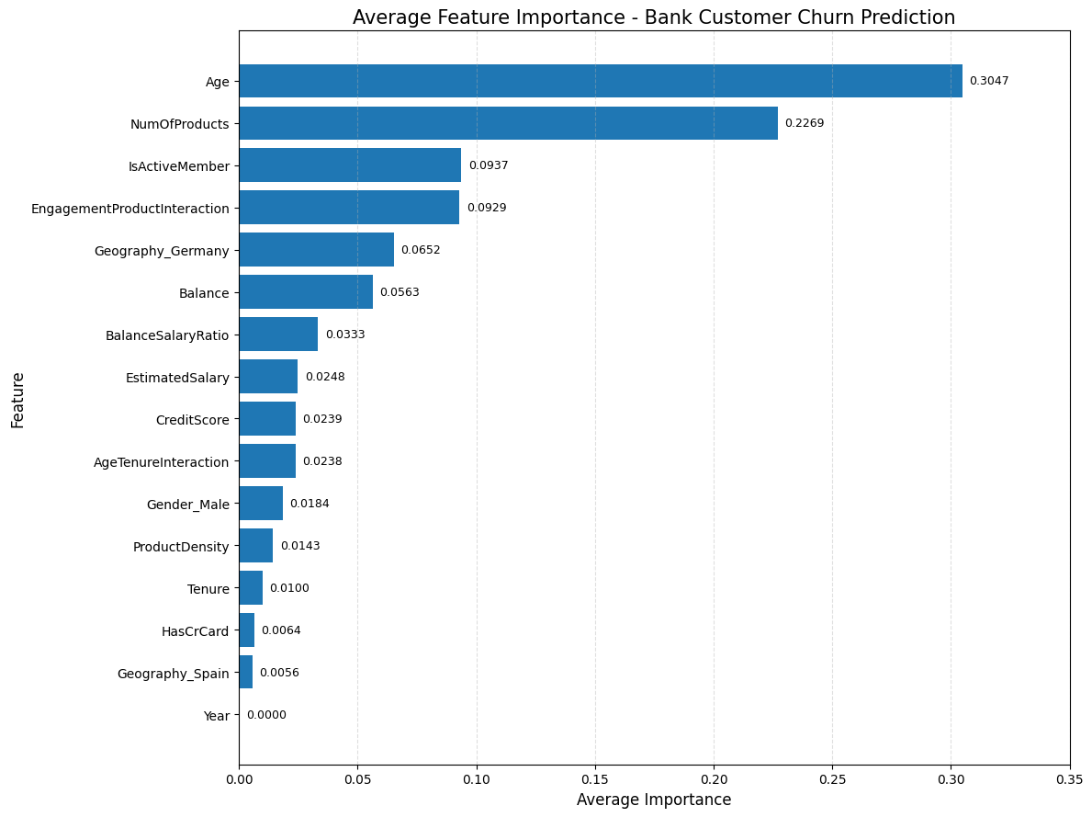

Overall conclusion
Age and the number of products together account for approximately 53.16% of the reported average feature importance. These are the two leading predictors in your combined analysis. Customer activity, engagement-product interaction, geography, and account balance also contribute to churn prediction.

10.2 SHAP VALUE ANALYSIS
SHAP (SHapley Additive exPlanations) analysis helps explain how each feature influences the predictions made by your churn prediction models. Based on the four plots provided, we can identify the most influential features, understand their impact on churn predictions, and compare the model explanations.
1. Understanding the SHAP Summary Plots
The two bottom plots are SHAP summary (beeswarm) plots. The top two plots show SHAP interaction values for CreditScore and Year.
- X-axis (SHAP value): Indicates how a feature influences the model output. Positive values push the prediction toward the model's positive class; negative values push it away.
- Each dot: Represents one customer.
- Red/pink dots: Higher feature values.
- Blue dots: Lower feature values.
- Features at the top: Generally have greater overall influence, usually because their mean absolute SHAP values are higher.
Assuming your positive class is Exited = 1, positive SHAP values generally indicate increased predicted churn, and negative values indicate reduced predicted churn. The exact interpretation depends on the model's output scale and SHAP configuration.
1. Decision Tree – SHAP Analysis

The first image contains a SHAP interaction summary for CreditScore and Year, rather than a complete SHAP summary plot for all features.
- CreditScore: Most SHAP interaction values are concentrated around zero, indicating relatively small contributions for most observations in the displayed interactions. A few observations show small positive or negative effects.
- Year: The interaction values are concentrated almost entirely around zero, suggesting little contribution from Year in the displayed model interactions.
- Interaction effects: The narrow distributions suggest that the displayed interactions between CreditScore and Year are generally weak.
Interpretation: CreditScore appears to have limited interaction effects in this visualization, while Year contributes very little. However, this plot alone does not establish the overall importance of CreditScore compared with other features.

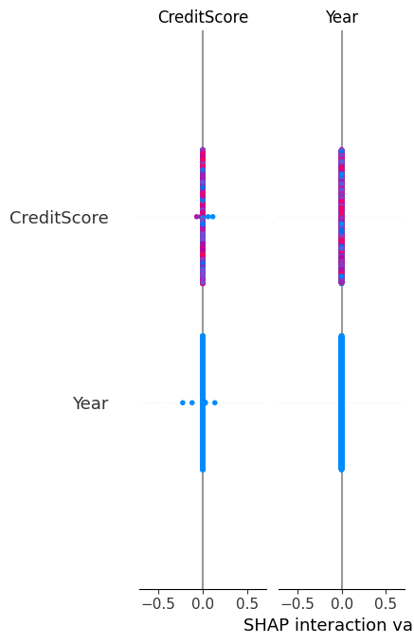
2. Age
Higher age values (red dots) extend toward positive SHAP values, while lower age values (blue dots) tend to appear closer to zero or on the negative side. This indicates that oldercustomers often receive higher churn predictions in this model.

2. Random Forest – SHAP Analysis
Image 2
The second image also focuses on SHAP interactions between Year and CreditScore.
- Year: SHAP interaction values are concentrated near zero, indicating negligible interaction contributions for most observations.
- CreditScore: The distribution is wider than the Year distribution, showing that CreditScore has some variation in its contribution across observations.
- Interaction effects: Most values remain close to zero, suggesting that the displayed interaction between these two features is limited.
Interpretation: Year appears to have little influence through the displayed interactions. CreditScore has more variation, but its overall contribution should be assessed using the full SHAP summary plot.
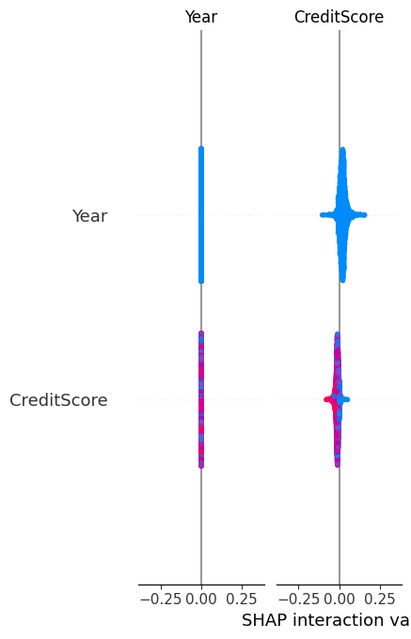

3. Gradient Boosting – SHAP Analysis
Image 3
The third image is a SHAP summary (beeswarm) plot, showing the direction and magnitude of feature contributions.
NumOfProducts
This feature shows a wide range of SHAP values, including strong positive contributions for some observations and negative contributions for others. Its relationship with churn may be nonlinear. Customers with different numbers of products can have substantially different predicted risks.
Age
Age has a broad SHAP distribution. Higher feature values (pink) extend toward positive SHAP values, suggesting that older customers tend to receive higher churn predictions in this model.
Geography_Germany
High feature values, representing customers in Germany when the variable is one-hot encoded, tend toward positive SHAP values. This suggests that being in Germany increases predicted churn risk for some customers relative to the encoded reference category.
IsActiveMember
High values (active members) tend toward negative SHAP values, while low values (inactive members) tend toward positive values. This indicates that inactive customers generally receive higher predicted churn risk.
Balance and BalanceSalaryRatio
These features show mixed positive and negative contributions. Their effects vary by customer, suggesting that balance-related information interacts with other customer characteristics.
Other observations:
- Gender_Male: High values tend toward negative SHAP values, while low values tend toward positive values in this plot.
- ProductDensity: Higher values show some positive contributions, although most effects are small.
- Year: SHAP values are essentially zero, indicating negligible predictive contribution in this model.
Interpretation: Gradient Boosting relies strongly on the number of products, age, geography, and customer activity. These patterns can help identify customer groups that may need targeted retention strategies.

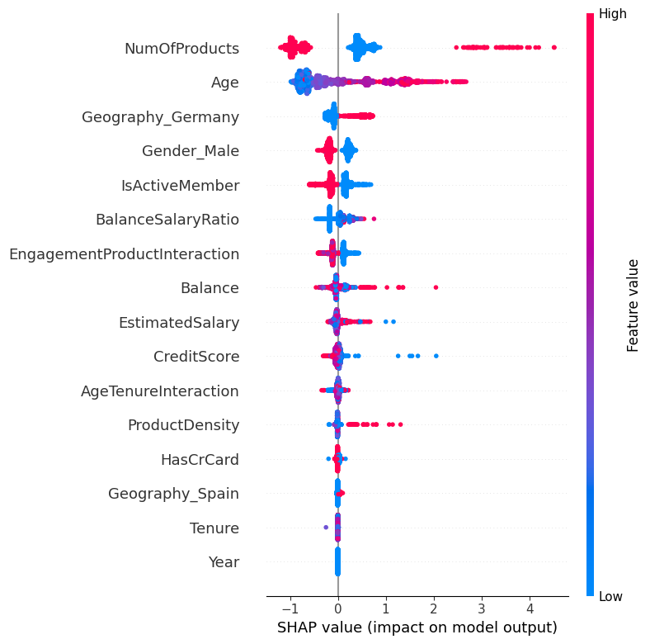

4. XGBoost – SHAP Analysis
The fourth image shows similar patterns, but some features have different rankings and contribution distributions.
- Age: Shows a wide range of positive SHAP values at higher feature values, indicating that older customers generally receive higher predicted churn risk.
- NumOfProducts: Has strong positive and negative SHAP contributions. Some observations have very large positive values, while others have negative values. This suggests a potentially nonlinear relationship between product count and churn.
- IsActiveMember: Inactive customers tend toward positive SHAP values, whereas active customers tend toward negative values. Customer activity appears to be an important protective signal in the model.
- Geography_Germany: High values tend toward positive SHAP contributions, suggesting elevated predicted churn risk for customers in Germany.
- Gender_Male: High values tend toward negative SHAP values, while low values tend toward positive contributions.
- Balance and BalanceSalaryRatio: Show moderate and mixed effects, with some observations contributing positively to churn predictions.
- Year: Has SHAP values concentrated at or very close to zero, indicating little predictive contribution.
Interpretation: XGBoost identifies age, product count, activity status, and geography as important factors in its churn predictions. The spread of SHAP values also suggests that the effects of some features differ considerably across customers.

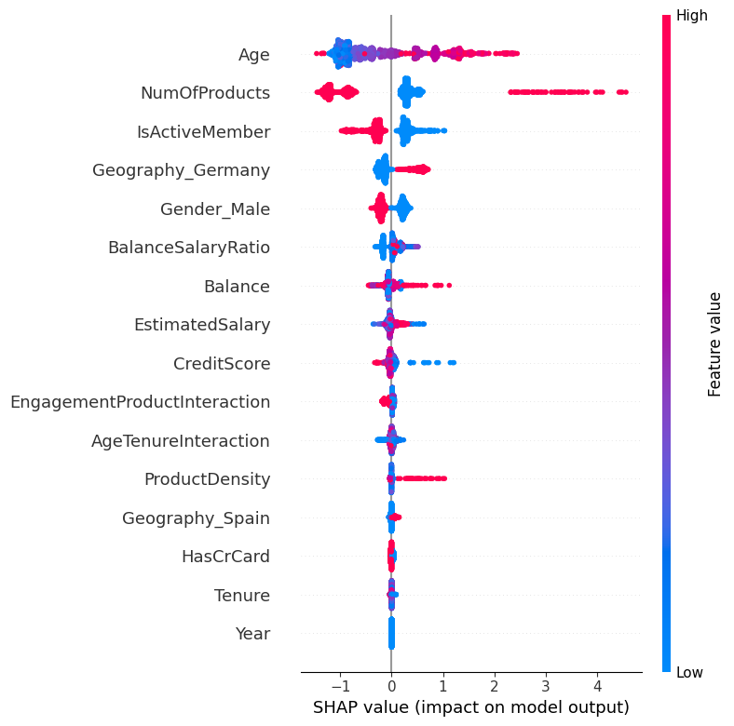

5. Comparison of the four models
Model | Main observation | Practical implication
Decision Tree | Displayed CreditScore and Year interactions are mostly near zero | These particular interactions appear weak
Random Forest | CreditScore shows more variation than Year in the displayed interactions | CreditScore may contribute for selected customers
Gradient Boosting | Age, NumOfProducts, Geography_Germany, and IsActiveMember show notable effects | Focus retention analysis on age, product holdings, location, and engagement
XGBoost | Age, NumOfProducts, and IsActiveMember show strong and varied effects | Use individual SHAP explanations to investigate high-risk customers

6. Understanding the SHAP plot colors and values
Pink / red — High feature values
Indicates observations with higher values of the feature, such as older ages or IsActiveMember = 1.
Blue — Low feature values
Indicates observations with lower values, such as younger ages or IsActiveMember = 0.
SHAP values
- Positive values (right of zero) push the model output toward the predicted churn class, assuming the explained output is churn probability or churn-oriented model output.
- Negative values (left of zero) push the prediction away from churn.
- Values near zero indicate little contribution to that particular prediction.

10.3 Partial Dependence Plot (PDP) Analysis – Gradient Boosting Model
1. Introduction
Partial Dependence Plots (PDPs) were generated to interpret the Gradient Boosting model developed for the Bank Customer Churn Prediction project. PDPs illustrate how changes in individual features influence the model's average predicted output while averaging over the other features in the dataset. This analysis helps identify important patterns associated with customer churn and supports the development of targeted customer-retention strategies.
The analysis focuses on six features: Age, NumOfProducts, IsActiveMember, Geography_Germany, Balance, and EngagementProductInteraction.
2. Feature-wise analysis and interpretation
2.1 Age
The PDP shows a clear upward trend in the partial dependence values as customer age increases. The values remain relatively low for younger customers, particularly below approximately 40 years, and rise more noticeably from the early 40s onward. The curve reaches higher levels among customers in their 50s before stabilizing slightly toward the upper end of the displayed age range.
Interpretation: Age appears to have a substantial positive relationship with the Gradient Boosting model's predicted churn output. Older customers generally receive higher predicted churn scores than younger customers, according to this model.
Business recommendation: The bank should monitor customer satisfaction and engagement among older customers and consider personalized retention initiatives for groups with elevated predicted churn risk.
2.2 Number of Products (NumOfProducts)
The PDP shows a nonlinear relationship between the number of products held and the model's predicted output. The partial dependence value decreases from one product to two products, then rises sharply for three products and increases further for four products.
Interpretation: The model associates different product counts with substantially different predicted churn outputs. In particular, the sharp increase for three and four products suggests that these groups may warrant further investigation. However, the graph represents average model behavior and does not establish that holding more products causes churn.
Business recommendation: Analyze churn rates, customer profiles, and service experiences separately for customers holding one, two, three, or four products. Pay particular attention to the three- and four-product groups to determine whether specific customer segments need additional support.
2.3 Active Membership (IsActiveMember)
The PDP shows a slight downward trend as the feature changes from 0 to 1. Since 0 represents an inactive member and 1 represents an active member, the model predicts a slightly lower output for active members.
Interpretation: Active membership appears to be associated with a modest reduction in predicted churn output. This suggests that customer engagement may help distinguish customers with different levels of churn risk.
Business recommendation: Strengthen customer engagement through personalized communication, relevant banking services, digital banking support, and loyalty initiatives. Monitor whether these initiatives improve retention over time.
2.4 Geography – Germany (Geography_Germany)
The PDP shows a gradual upward trend as Geography_Germany changes from 0 to 1. The partial dependence value increases from a negative value toward approximately zero.
Interpretation: The model associates customers from Germany with a slightly higher predicted churn output than customers outside Germany, on average, according to this feature's partial dependence curve.
Business recommendation: Examine regional churn rates and customer feedback to identify possible differences in service expectations, customer experience, or product suitability. Geographic differences should be investigated rather than assumed to be the cause of churn.
2.5 Balance
The Balance PDP remains relatively stable at lower values and shows small fluctuations across the displayed balance range. The partial dependence values are mostly negative, with modest changes as the balance increases.
Interpretation: Balance appears to have a comparatively limited and nonlinear effect on the model's average predicted output over much of the displayed range. The curve does not show a strong, consistent upward or downward trend.
Business recommendation: Balance should be considered alongside other factors, such as age, product holdings, and customer engagement, rather than used alone to identify customers at risk of churn.
2.6 EngagementProductInteraction
The PDP shows a generally negative partial dependence value across the displayed feature range, with a small downward change at lower values followed by relatively stable values.
Interpretation: The model's average predicted output changes only modestly across most of the displayed values of EngagementProductInteraction. This suggests a limited average marginal effect in this PDP, although individual customer effects may differ.
Business recommendation: Evaluate this engineered feature alongside the underlying engagement and product variables. If its business meaning is unclear, document how it was calculated and verify whether it improves predictive performance.

3. Summary of findings
Feature | Observed PDP pattern | Interpretation
Age | Strong upward trend | Older age is associated with higher predicted churn output
NumOfProducts | Sharp nonlinear changes | Product count is associated with substantially different predictions
IsActiveMember | Slight downward trend | Active membership is associated with lower predicted churn output
Geography_Germany | Gradual upward trend | Germany is associated with a slightly higher predicted output
Balance | Mostly stable with small fluctuations | Limited average effect across much of the range
EngagementProductInteraction | Mostly stable and negative | Modest average changes in predicted output

4. Business implications
The PDP analysis provides several insights for customer-retention planning:
- Age-based retention: Investigate why older customer groups receive higher predicted churn scores and develop relevant retention strategies.
- Product portfolio analysis: Examine customers with three or four products to understand the sharp changes in model predictions.
- Customer engagement: Encourage active participation in banking services and monitor its relationship with customer retention.
- Geographic analysis: Investigate regional differences in churn and customer satisfaction.
- Multivariable assessment: Avoid relying on account balance or the engineered interaction feature in isolation when prioritizing retention efforts.

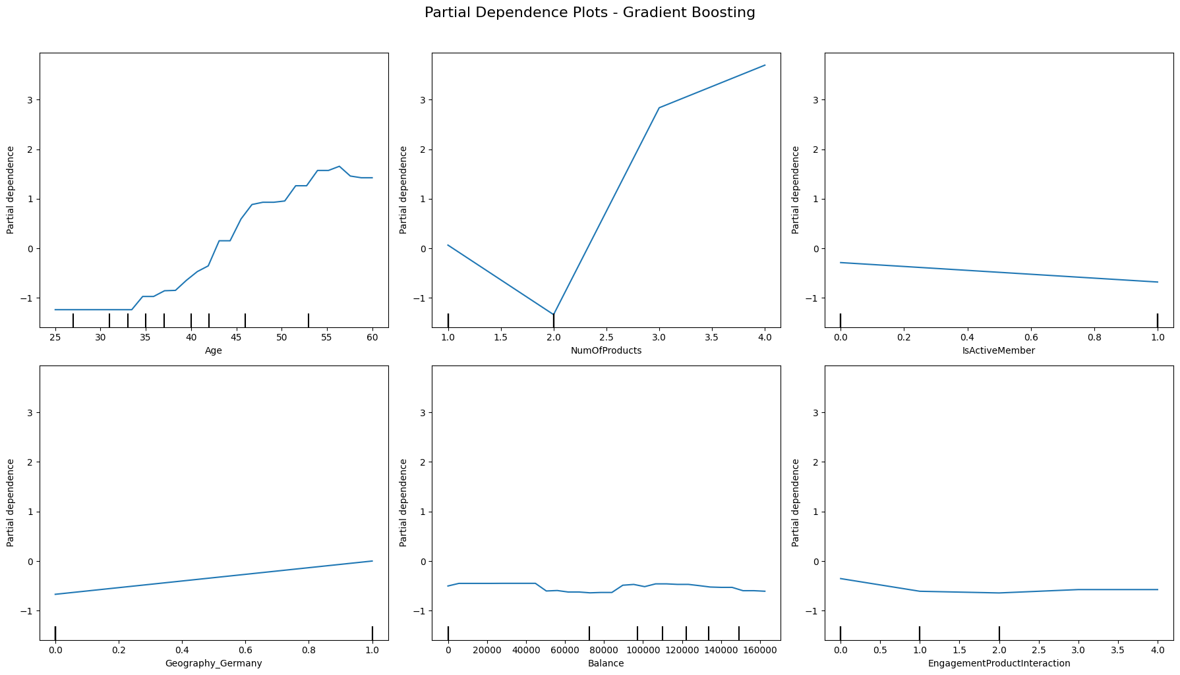

5. Conclusion
The Partial Dependence Plot analysis of the Gradient Boosting model indicates that Age and NumOfProducts exhibit the most pronounced changes in the model's average predicted output among the six displayed features. Age shows an increasing trend, while the number of products exhibits a nonlinear relationship. Active membership is associated with a slight reduction in predicted output, whereas Geography_Germany shows a modest upward trend. Balance and EngagementProductInteraction demonstrate comparatively limited changes across much of their displayed ranges.
These findings help explain how the Gradient Boosting model uses customer characteristics to generate churn predictions and can guide further investigation into high-risk customer segments. PDPs describe average model behavior rather than causal relationships, so the findings should be validated against observed churn rates, test-set performance, and individual-level explanations such as SHAP values.
Technical note for your report: The vertical axis is labelled Partial Dependence, not churn probability. Therefore, unless your code explicitly plots the positive-class probability, describe the values as changes in the model's predicted output rather than percentages or direct probabilities of churn.
Predictive Target Definition
- Target Variable: Exited
- 1 → Customer churned (left the bank).
- 0 → Customer retained (continued banking with the bank).
- Prediction Output:
1. Churn Probability (0–1): The model estimates the probability that a customer will leave the bank. For example, a probability of 0.85 indicates an estimated churn probability of 85%.
2. Binary Churn Flag (Threshold-Based): The predicted probability is converted into a binary classification using a selected threshold, typically 0.50.
- Probability ≥ 0.50 → Predict churn (1).
- Probability < 0.50 → Predict retention (0).
- Mathematical representation
$$\hat{y}=\left\{\begin{matrix}1, & P\left(\text{Exited}=1∣X\right)≥t \\ 0, & P\left(\text{Exited}=1∣X\right)<t\end{matrix}\right.$$

Where:
- X represents the customer's input features.
- P{Exited}=1| X) is the predicted probability of churn.
- t is the classification threshold, typically 0.50.

Overall Conclusion
- The Bank Customer Churn Prediction project successfully demonstrates how machine learning techniques can be used to identify customers who are likely to leave a bank and support data-driven customer-retention strategies. The project involved data preprocessing, exploratory data analysis, feature engineering, model development, performance evaluation, and model interpretation to understand the factors associated with customer churn.
- Four machine learning algorithms—Decision Tree, Random Forest, Gradient Boosting, and XGBoost—were explored and compared to evaluate their ability to predict customer churn. Feature importance analysis identified Age and NumOfProducts as the most influential features across the combined model analysis, followed by IsActiveMember and EngagementProductInteraction. These findings suggest that customer demographics, product holdings, and engagement patterns provide valuable information for predicting churn.
- SHAP analysis was used to interpret individual feature contributions and understand how different customer characteristics influence model predictions. Partial Dependence Plots for the Gradient Boosting model further illustrated the relationships between selected features and the model's average predicted output. In particular, age showed an increasing relationship with predicted churn output, while the number of products exhibited a nonlinear pattern. Active membership was generally associated with lower predicted churn output. These findings help explain the model's behaviour and identify areas for further investigation.
- The project also established a predictive target using the Exited variable, where 1 represents a customer who churned and 0 represents a retained customer. The model can generate a churn probability between 0 and 1 and convert it into a binary prediction using a selected classification threshold. This provides a practical foundation for identifying potentially high-risk customers and prioritizing retention activities.
- From a business perspective, the bank can use the insights to develop targeted engagement campaigns, investigate customer groups with higher predicted churn risk, improve customer satisfaction, and tailor banking products to customer needs. However, model predictions should be evaluated using appropriate test-set metrics, and retention strategies should be validated against actual customer outcomes before implementation.
- In conclusion, this project demonstrates the practical value of machine learning and explainable AI in banking analytics. By combining churn prediction with feature importance, SHAP explanations, and partial dependence analysis, the project provides a framework for understanding customer behaviour, supporting proactive retention decisions, and improving customer relationship management. The ultimate objective is to help the bank make informed decisions, strengthen customer loyalty, and reduce avoidable customer attrition.

The Bank Customer Churn Prediction project successfully demonstrates how machine learning techniques can be used to identify customers who are likely to leave a bank and support data-driven customer-retention strategies. The project involved data preprocessing, exploratory data analysis, feature engineering, model development, performance evaluation, and model interpretation to understand the factors associated with customer churn.
Four machine learning algorithms—Decision Tree, Random Forest, Gradient Boosting, and XGBoost—were explored and compared to evaluate their ability to predict customer churn. Feature importance analysis identified Age and NumOfProducts as the most influential features across the combined model analysis, followed by IsActiveMember and EngagementProductInteraction. These findings suggest that customer demographics, product holdings, and engagement patterns provide valuable information for predicting churn.
SHAP analysis was used to interpret individual feature contributions and understand how different customer characteristics influence model predictions. Partial Dependence Plots for the Gradient Boosting model further illustrated the relationships between selected features and the model's average predicted output. In particular, age showed an increasing relationship with predicted churn output, while the number of products exhibited a nonlinear pattern. Active membership was generally associated with lower predicted churn output. These findings help explain the model's behaviour and identify areas for further investigation.
The project also established a predictive target using the Exited variable, where 1 represents a customer who churned and 0 represents a retained customer. The model can generate a churn probability between 0 and 1 and convert it into a binary prediction using a selected classification threshold. This provides a practical foundation for identifying potentially high-risk customers and prioritizing retention activities.
From a business perspective, the bank can use the insights to develop targeted engagement campaigns, investigate customer groups with higher predicted churn risk, improve customer satisfaction, and tailor banking products to customer needs. However, model predictions should be evaluated using appropriate test-set metrics, and retention strategies should be validated against actual customer outcomes before implementation.
In conclusion, this project demonstrates the practical value of machine learning and explainable AI in banking analytics. By combining churn prediction with feature importance, SHAP explanations, and partial dependence analysis, the project provides a framework for understanding customer behaviour, supporting proactive retention decisions, and improving customer relationship management. The ultimate objective is to help the bank make informed decisions, strengthen customer loyalty, and reduce avoidable customer attrition.

Overall Recommendations:
Based on the exploratory data analysis, feature importance comparison, SHAP analysis, and Partial Dependence Plots, the following recommendations are proposed to help the bank improve customer retention and make data-driven business decisions.
1. Implement Proactive Customer Retention Strategies
The bank should use the trained machine learning model to identify customers with a high predicted probability of churn. These customers can be prioritized for personalized communication, relationship management, and retention campaigns before they leave the bank.
2. Focus on Age-Based Customer Segmentation
Age emerged as the most influential feature in the combined feature importance analysis. The bank should investigate churn patterns across different age groups and develop suitable banking products, services, and communication strategies for customer segments with higher observed churn rates.
3. Investigate Product-Holding Patterns
NumOfProducts was the second most important feature in the combined analysis. The bank should examine churn rates across customers holding different numbers of products to identify potentially dissatisfied or underserved segments. Product recommendations should be based on customer needs rather than simply increasing the number of products held.
4. Improve Customer Engagement
IsActiveMember and EngagementProductInteraction also showed substantial predictive importance. The bank should encourage meaningful engagement through personalized service notifications, digital banking support, relevant offers, and regular follow-ups. The effectiveness of these initiatives should be measured using actual retention outcomes.
5. Investigate Geographic Differences
The feature Geography_Germany contributed to churn predictions across the model analysis. The bank should investigate regional differences in customer satisfaction, service usage, product preferences, and churn rates. Retention strategies should be tailored to verified regional needs rather than assuming geography itself causes churn.
6. Use Explainable AI for Better Decisions
SHAP analysis and Partial Dependence Plots should be used alongside model predictions to understand which features influence churn estimates. These techniques can help analysts identify important patterns, explain individual predictions, and support more transparent business decisions.
7. Optimize the Classification Threshold
The bank should not automatically rely on a threshold of 0.50 for classifying customers as likely to churn. The threshold should be selected based on model performance, the cost of missed churners, the cost of unnecessary retention campaigns, and the bank's available resources. Precision, recall, F1-score, and precision-recall analysis can support this decision.
8. Monitor and Improve Model Performance
The selected model should be evaluated on unseen test data using accuracy, precision, recall, F1-score, ROC-AUC, and a confusion matrix. After deployment, the bank should monitor prediction quality, data changes, and customer behaviour over time and retrain the model when necessary.
9. Build a Customer Churn Monitoring Dashboard
A dashboard can provide business stakeholders with an overview of predicted churn risk, high-risk customer segments, feature importance, and retention campaign outcomes. It should display churn probabilities, clearly distinguish predictions from actual churn, and support prioritization of follow-up activities.
10. Protect Customer Data and Ensure Fairness
Customer information should be handled securely and in accordance with applicable privacy requirements. The bank should assess whether model predictions produce unfair outcomes across customer groups and ensure that retention decisions remain transparent, proportionate, and subject to appropriate human oversight.
Expected Business Benefits
- Early identification of customers at elevated risk of churn.
- More targeted and efficient retention campaigns.
- Better understanding of customer needs and engagement patterns.
- Improved allocation of customer relationship management resources.
- More transparent, measurable, and data-driven business decisions.
- Potential improvement in customer retention and long-term profitability.

Final Recommendation
The bank should integrate churn prediction into its customer relationship management process, using the selected model to prioritize customers for proactive intervention. Age, number of products, customer activity, and engagement-related features should receive particular attention during churn analysis, while SHAP and PDP results should guide further investigation rather than be treated as proof of causation.
The bank should begin with a controlled pilot, measure retention outcomes against a suitable comparison group, and expand the initiative only when the results demonstrate measurable business value. This approach will help transform the project from a predictive analytics exercise into a practical customer-retention strategy.
----------------------------------------------------------THE END----------------------------------------

